GOVERNMENT ARTS AND SCIENCE COLLEGE SADAIYAMPATTU, KALLAKURICHI ANNAMALAI UNIVERSITY


PG DEPARTMENT OF COMPUTER SCIENCE

PROJECT REPORT
A CRM APPLICATION FOR
THE CHAISHOP&CO

Submitted By:
Team Leader : Arun G
Team member : Thirupathi K Team member : Dhanush M Team member : Santhosh D Team member : Azhaguraj G

Under the Guidance:
S.MURUGAN.,M.Sc.,M.Phil
Guest Lecturer
Head of The Department:

Prof. D. KRISHNAKUMAR., M.C.A., M.Phil., PGDCA., SET PG DEPARTMENT OF COMPUTER SCIENCE

PROJECT REPORT





Submitted by :
- Arunkumar.G-TEAM Leader
- Thirupathi.k
- Dhanush.M
- Santhosh.D
- Azhaguraj.G

Prepared for :
ChaiShop Management

A C R M A P P L I C AT I O N F O R
T H E C H A I S H O P & C O

Under the Guidance of
S.MURUGAN.,M.SC.,M.Phil
Guest Lecturer
Head of the Department
prof.D.KRISHNAKUMAR.,M.C.A.,M.Phil.,PGDCA.,SET
PG DEPARTMENT OF COMPUTER SCIENCE

User Story:
As a sales representative at TheChaiShop&Co, I want to efficiently manage customer relationships and streamline sales processes using our CRM application.
I want to easily access and update employer details, as well as distinguish between online and offline customer records using record types, allowing for personalized interactions. Additionally, I need the application to automate sales calculations, such as order quantity and total bill amount, to ensure accurate and efficient transactions.
Moreover, I require the ability to generate insightful reports and dashboards to summarize and analyze sales data effectively, aiding in decision-making and strategy development. Lastly, I would like the application to automate email notifications to customers on their birthdays, informing them of special offers tailored to celebrate their special day, enhancing customer engagement and loyalty.

INTRODUCTION

Project Overview:

The project “A CRM Application for TheChaiShop&Co” focuses on developing a Salesforce-based Customer Relationship Management (CRM) system to manage customer, employer, and enterprise accounts efficiently. The system automates sales processes, maintains customer records, generates reports, and improves customer engagement through automated notifications.

The project user story and objectives are defined in the initial section of the document

Purpose:

The purpose of this project is to:
    - Streamline customer relationship management
    - Automate billing and order calculations
    - Improve data accuracy
    - Enable data-driven decision-making
    - Enhance customer engagement through email automation

IDEATION PHASE

Problem Statement (Customer Problem Statement Template)


PS
I am (Customer)
I’m trying to
But
Because
Which makes me feel
PS-1
Sales Representati ve
Manage customer
Calculations
are
often
orders and incorrect billing
PS-2
Store Manager
Monitor sales customer records
Reports are and delayed and
incomplete
Order quantity and billing are manual
Data is stored in multiple files
There is no automated communicat ion
Stressed and inefficient
Confused and dissatisfied
PS-3
Customer
Receive personalized
I do not get
offers updates
and notifications
timely
Disconnecte d and undervalued

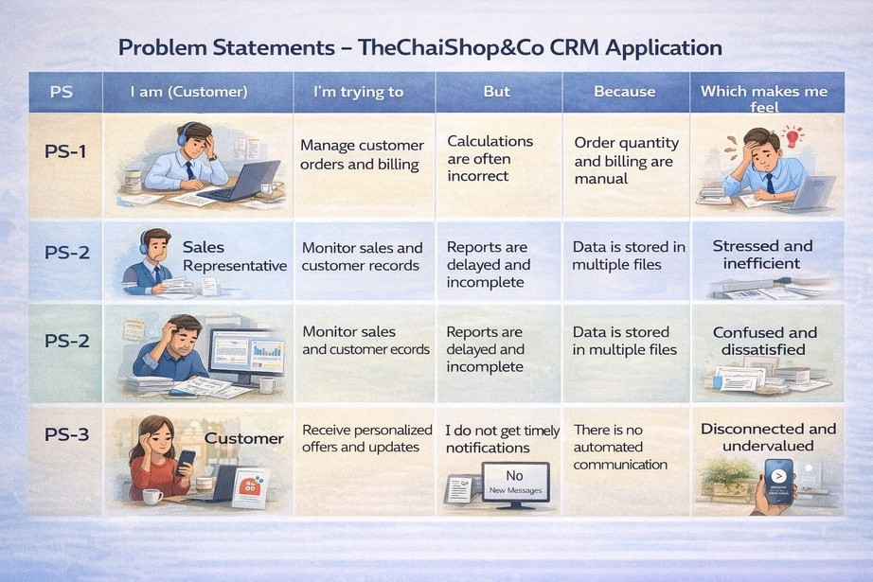

  - Empathy Map Canvas

Target Users

    - Sales Representatives
    - Managers
    - System Administrators
    - Business Analysts

Empathy Analysis


Aspect
Think & Feel
Description
Need accurate customer data and reports

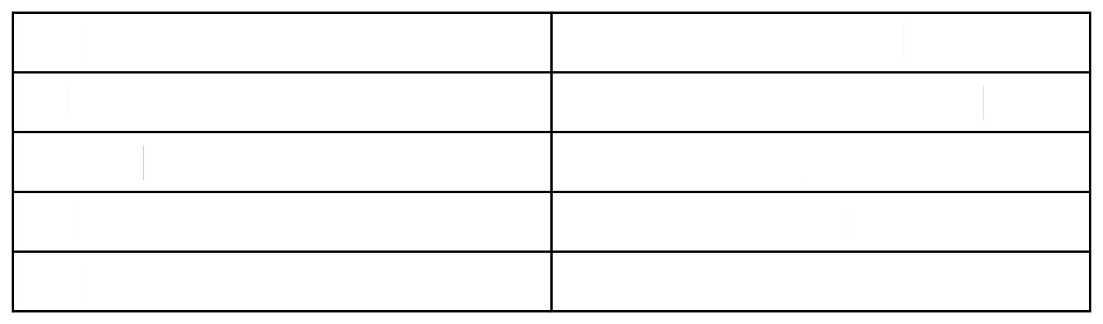
Hear See
Say & Do Pain
Gain
Feedback from management Multiple registers and spreadsheets Enter data manually
Errors, delays, data loss
Automation, fast reports

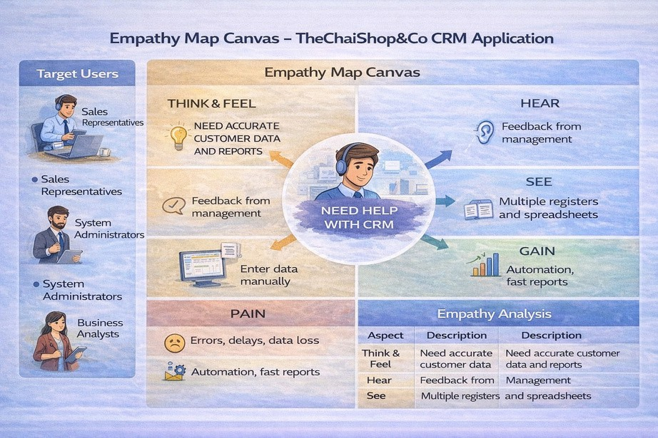

  - Brainstorming

Brainstormed Ideas

    - Manual CRM system
    - Excel-based management
    - Web-based CRM

    - Salesforce-based CRM
    - Automatedemail system

Selected Idea:
Salesforce-basedCRM Application for TheChaiShop&Co..

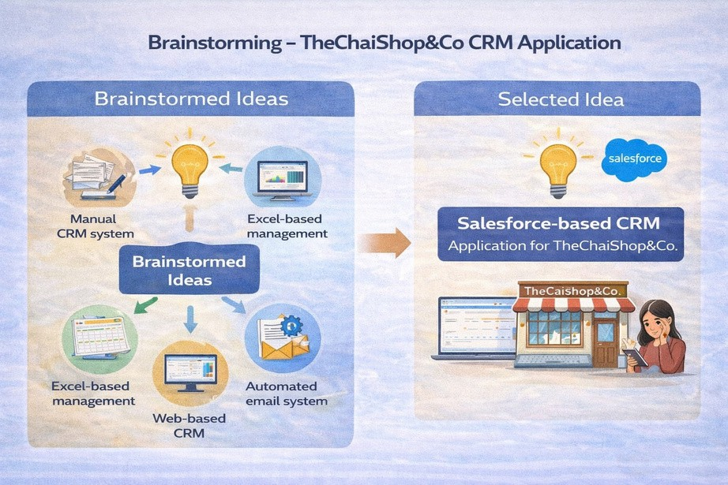

REQUIREMENT ANALYSIS PHASE
  - Customer Journey Map
Journey Stages:
    - Login
    - Access CRM Application
    - Enter Customer Data

    - Generate Orders
    - Calculate Bills
    - View Reports
    - Decision Making

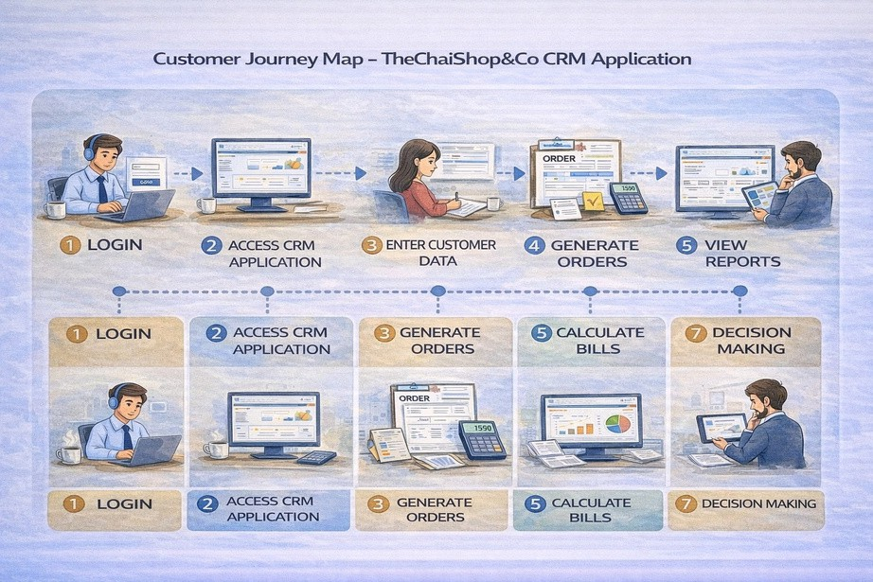

  - Solution Requirements

Functional Requirements


FR No
FR-1
Requirement
User Login

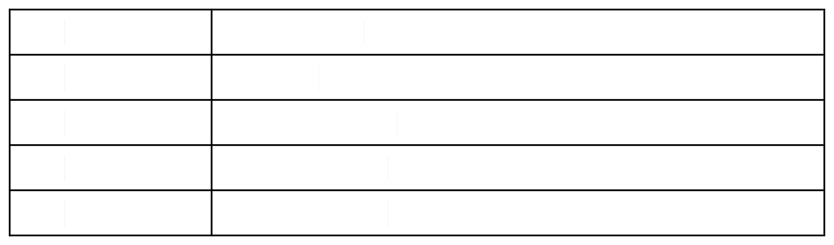
FR-2 FR-3 FR-4 FR-5
FR-6
Object Creation Data Entry
Billing Automation
Report
Generation
Email Automation

Non-Functional Requirements NFR-1: Usability
The system should be easy to use for sales representatives, managers, administrators, and analysts without requiring technical training.

Requirements :

- Simple and intuitive user interface
- Clear navigation menus
- Easy-to-understand forms
- User-friendly dashboards

Example:
A new sales employee should be able to log in, enter customer details, and generate orders within a few minutes without help.
Salesforce Lightning UI provides drag-and-drop features and easy navigation.

NFR-2: Security

The system must protect customer and business data from unauthorized access.

Requirements:

- Role-based access control
- Secure login authentication
- Encrypted data storage

- Data backup and recovery

Examples:
- Profiles and permission sets
- Object-level and field-level security
- Restricted billing access
- Secure login and password policies

NFR-3: Reliability
The CRM system should work correctly at all times and store data accurately without loss.

Requirements:

- Automatic data saving
- Regular system backups
- Error handling mechanisms
- Stable cloud environment

Example :
If a user enters order data and the internet disconnects, the system should save the information and restore it later.
Salesforce cloud ensures automatic backups.

NFR-4: Performance
The system should respond quickly and handle large amounts of data efficiently.

Requirements:

- Fast page loading
- Quick report generation
- Smooth dashboard rendering
- Minimal delay

Example: When a manager generates monthly sales reports for hundreds of customers, the report should load within 2–3 seconds.
Optimized queries and caching improve speed.

NFR-5: Availability
The system should be accessible whenever required.

Requirements:
- 24/7 system availability
- Minimal downtime
- Cloud-based hosting
- Disaster recovery

Example: Managers should be able to access the CRM system during peak business hours, weekends, or late nights.
Salesforce cloud provides high uptime.

NFR-6: Scalability
The system should support business growth without affecting performance.

Requirements:
- Ability to handle more users
- Support increasing customer data
- Expandable storage
- Maintain system speed
Example: If TheChaiShop&Co expands to multiple branches, the CRM system should support thousands of customers without slowing down.
Salesforce infrastructure automatically scales.

  - Data Flow Diagram
User → Salesforce UI → Custom Objects → Validation Rules → Flows → Reports → Dashboards.

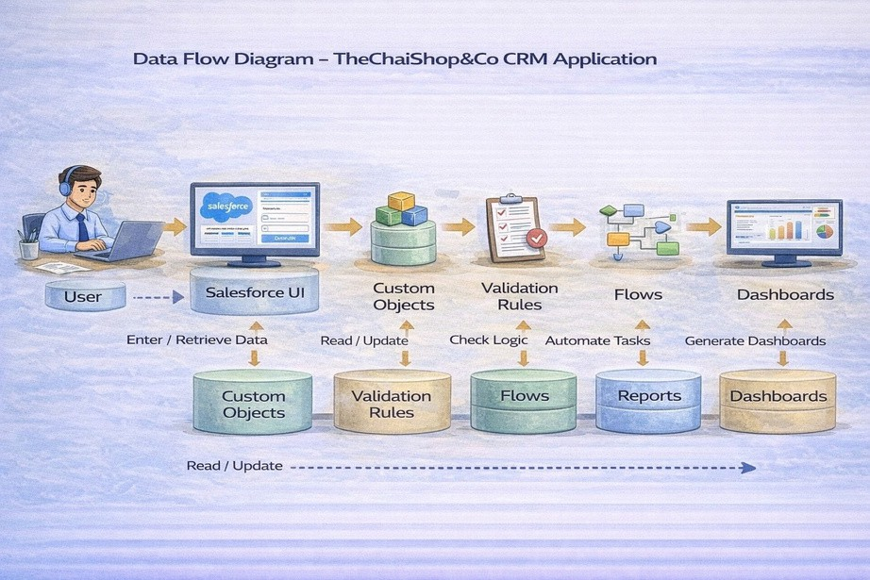

  - Technology Stack
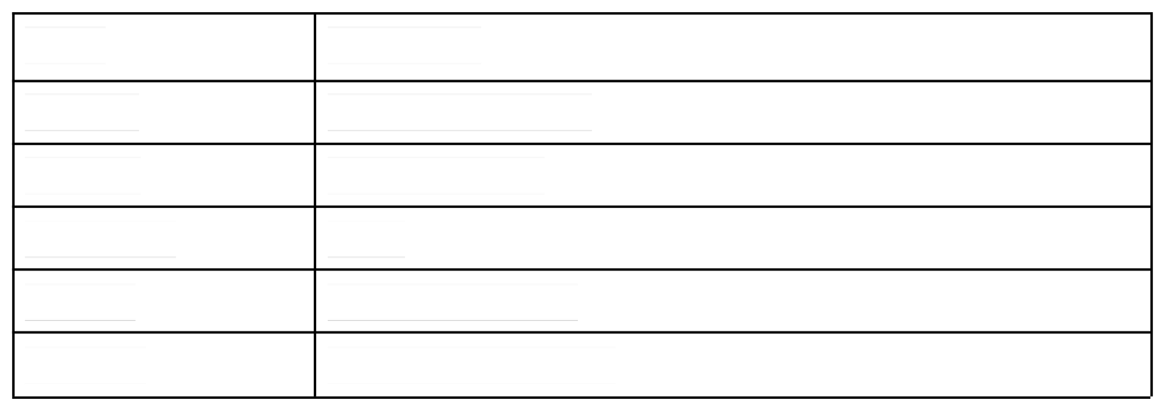
Layer Frontend Database Automation Backend
Analytics
Technology Salesforce Lightning Salesforce Cloud Flows
Salesforce Platform
Reports & Dashboards

PROJECT DESIGN PHASE
  - Problem–Solution Fit
The CRM system replaces manual records with automated data management. Cloud storage prevents data loss, dashboards improve analysis, and real-time reports eliminate delays. This ensures accurate and timely business insights generation.

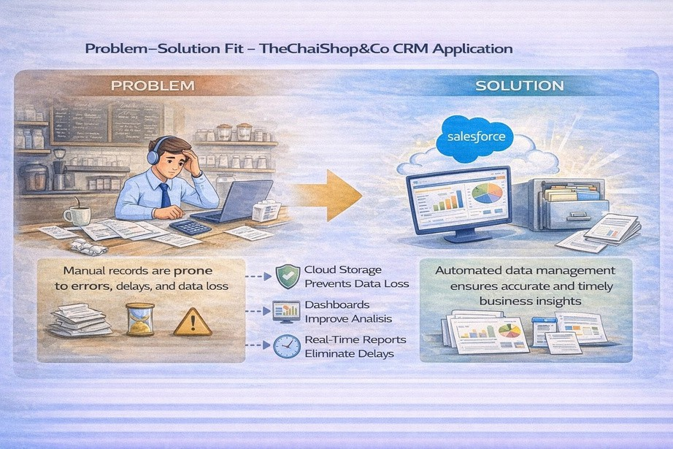

  - Proposed Solution

Functional Requirements

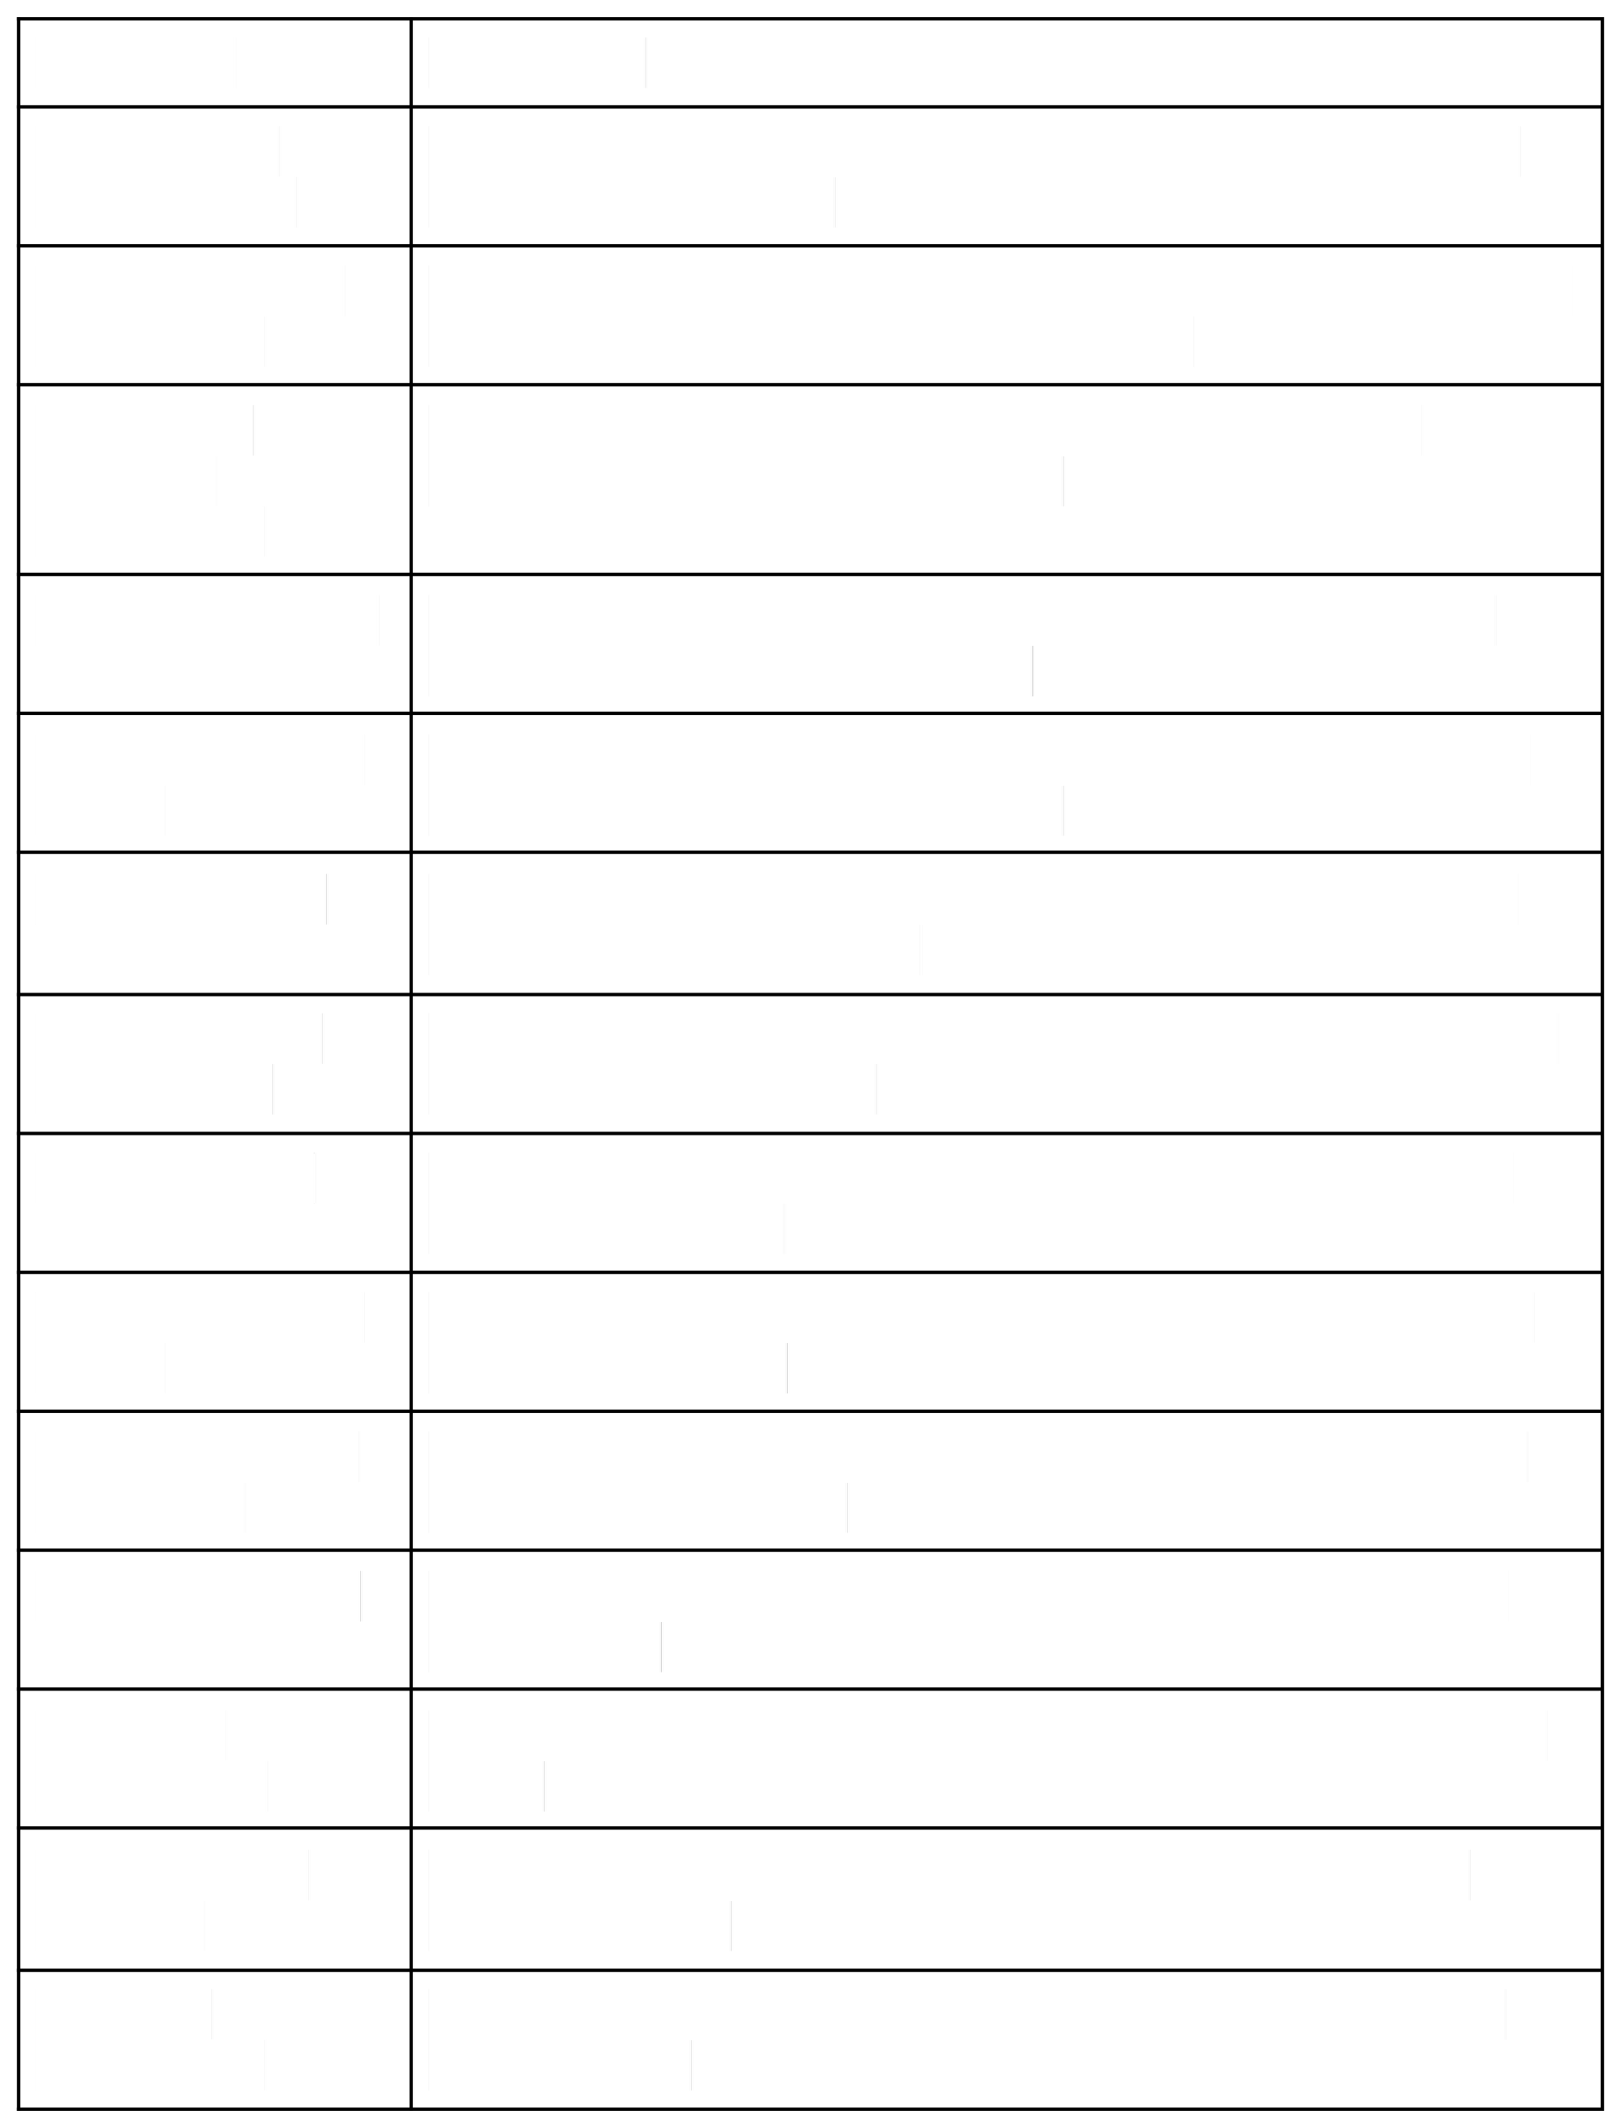
Parameter User Login & Authentication
Customer Record Management
Employer & Enterprise Management
Order Management

Automated Billing System
Validation Rules

Record Types & Page Layouts
Global Picklists

Email Notification System
Workflow & Flow Automation
Report Generation

Dashboard Visualization
Data Backup & Recovery
User Role Management

Description
Allows authorized users to securely log in to the CRM system using valid credentials.
Enables users to create, view, update, and delete customer details such as name, contact number, and address.
Allows management of employer and enterprise account information for business operations.

Supports creation and tracking of customer orders, including order quantity and product details.
Automatically calculates total bill amount using formula fields based on order quantity and pricing.
Ensures accurate data entry by validating fields such as phone number, PAN, and Aadhaar.
Provides different record types and layouts for various customer and enterprise categories.
Maintains standardized values for fields such as product type, category, and status.
Sends automated emails to customers for birthdays, offers, and order confirmations.
Automates tasks such as updating records and triggering alerts using Salesforce Flows.
Generates detailed reports on sales, customers, and enterprise performance.
Displays real-time analytics through interactive dashboards and charts.
Ensures secure storage and recovery of business data in the Salesforce cloud.
Controls system access using profiles and permission sets for different users.

  - Solution Architecture

Architecture Layers

- Presentation Layer – Lightning UI
- Application Layer – Flows and Logic
- Data Layer – Custom Objects
- Analytics Layer – Reports and Dashboards

This layered architecture ensures modularity, scalability, and maintainability.
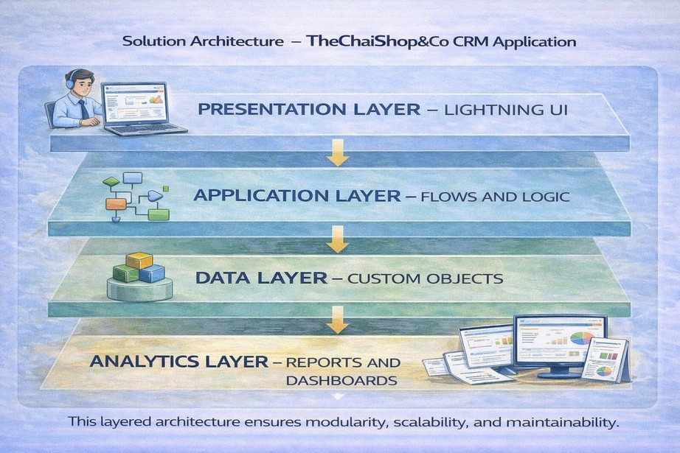

PROJECT PLANNING & SCHEDULING

Project Planning

    - The project followed an Agile-based development approach with defined milestones and sprints.
    - A Salesforce Developer account was created to set up the development environment.
    - Custom objects were designed to store customer, employer, and enterprise data.
    - Custom tabs and a Lightning Application were developed for easy system navigation.
    - Fields, relationships, and global picklists were configured to ensure data consistency.
    - Page layouts and record types were created based on user roles and customer categories.
Validation rules were implemented to prevent incorrect data entry.
    - Email templates and automated flows were developed for customer notifications.
    - Reports and dashboards were created for performance monitoring and analysis.
    - Regular sprint reviews and testing were conducted to track progress and resolve
    - issues.
The project was completed within the planned timeline through systematic

    - scheduling.
PUrsoedtuhcetbBealocwkltoegm,pSlaptreintot Sccrehaetdeuplreo,dauncdt bEasctkimlogataionnd (s4prMinatrskcsh)edule
Sprint
Sprint-1
Functional Requirement (Epic) Developer Setup
User Story Number USN-1
User Story / Task
Story Points
Priority
Team Member s Member1
Sprint-1
Data Modeling USN-2
As an admin, I want to create a Salesforce developer account so that I can configure and deploy the TheChaiShop&Co CRM application.
As an admin, I want to create Customer, Employer, and Enterprise objects so that business data can be stored and managed systematically.
As a user, I want separate tabs for each object so that I can easily navigate and manage CRM records within the application.
1
High
3
High
Member2
Sprint-2
Data Modeling
USN-3
3
High
Member3


Sprint Functional Requirement (Epic)
User Story Number
User Story / Task Story Points
Priority Team Member s

Sprint-2

Sprint-2

Sprint-2

Sprint-2

Sprint-3

Sprint-3
Data Modeling

Data Modeling

Data Modeling

Data Modeling

Automation

Automation
USN-4

USN-5

USN-6

USN-7

USN-8

USN-9
As a manager, I want a dedicated Lightning App so that all CRM operations are accessible from a single dashboard.
As an admin, I want to create customer and order fields so that complete sales and billing details can be captured accurately.
As a user, I want customized page layouts for different record types so that only relevant information is displayed during data entry
As a manager, I want separate record types for Retail and Enterprise customers so that different business categories can be managed efficiently.

As a system, I want to validate customer details and order inputs so that incorrect data entries are prevented.
As a system, I want automated flows to send email notifications so that customers receive timely updates and offers.
As a system, I want to
3 High

5 Medium

5 High

5 Medium

3 High

5 High
Member4

Member1

Member2

Member3

Member4

Member1

Sprint-4 | Automation | USN-10 | automatically calculate billing | 5 | High | Member2
 |  |  | amounts so that invoices are
 |  |  | generated without manual effort.
 |  |  | As a manager, I want sales and
Sprint-5 | Reports | USN-11 | customer reports so that I can | 4 | High | Member3
 |  |  | monitor business performance and
 |  |  | make informed decisions.
 |  |  | As a manager, I want visual
Sprint-6 | Dashboards | USN-12 | dashboards so that I can quickly | 4 | Medium | Member4
 |  |  | analyze sales, customers, and
 |  |  | enterprise performance.

Project Tracker, Velocity & Burndown Chart: (4 Marks)

Sprint | Total Story | Duratio | Sprint Start | Sprint End Date | Story Points | Sprint Release
 | Points | n | Date | (Planned) | Completed | Date (Actual)
 |  |  |  |  | (as on
 |  |  |  |  | Planned End
 |  |  |  |  | Date)
Sprint-1 | 20 | 6Days | 24 Oct 2022 | 29 Oct 2022 | 20 | 29 Oct 2022
Sprint-2 | 20 | 6Days | 31 Oct 2022 | 05 Nov 2022
Sprint-3 | 20 | 6Days | 07 Nov 2022 | 12 Nov 2022
Sprint-4 | 20 | 6Days | 14 Nov 2022 | 19 Nov 2022

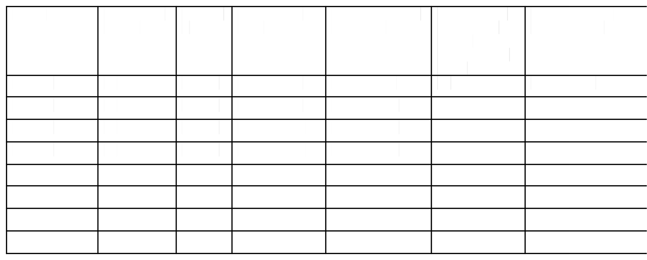
- Project Development Phase:

Project Flow
Milestone 1 : Creationofdeveloper account Milestone 2 : Object Creation
Milestone 3 : Tabs
Milestone 4 : The Lightning App Milestone 5 : Global Picklist
Milestone 6 : Fields and Relationships Milestone 7 : Creation of Page Layout Milestone 8 : Creation of Record Types Milestone 9 : Validation rules Milestone 10 : Email Templates Milestone 11 : Flows
Milestone 12 : Reports and Dashboards Milestone 13 : Conclusion

What you'll learn
- RealTimeSalesforce Project

- Standard and Custom objects
- Picklist Value sets
- Types of Fields & their relationships.
- Page Layouts
- Record Types
- Validation Rules
- Email Templates
- Flows
- Reports and Dashboards.

Implementation

Milestone 1 - Salesforce developer account creation :

Activity 1: Creating Developer Account:

Creating a developer org in salesforce.
- Go to https://developer.salesforce.com/signup
- On the sign up form, enter the following details:
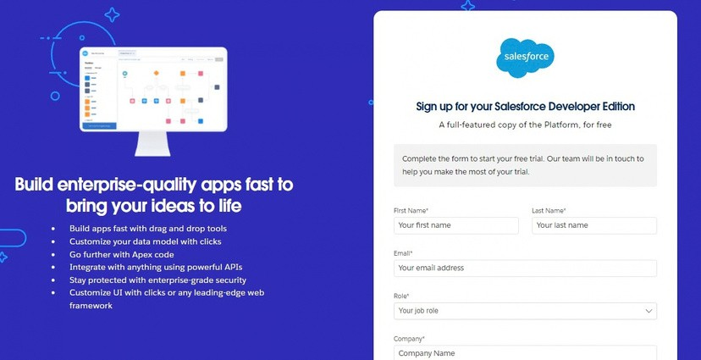

  - First name & Last name
  - Email
  - Role : Developer
  - Company : College or Company Name
  - County : India

  - Postal Code : pin code
  - Username : should be a combination of your name and company This need not be an actual email id, you can give anything in that format : username@organization.com
Click on sign me up after filling these.

Activity 2: Account Activation :

- Goto the inbox of the email that you used while signing up. Click on the verify account to activate your account. The email may take 5-10mins.
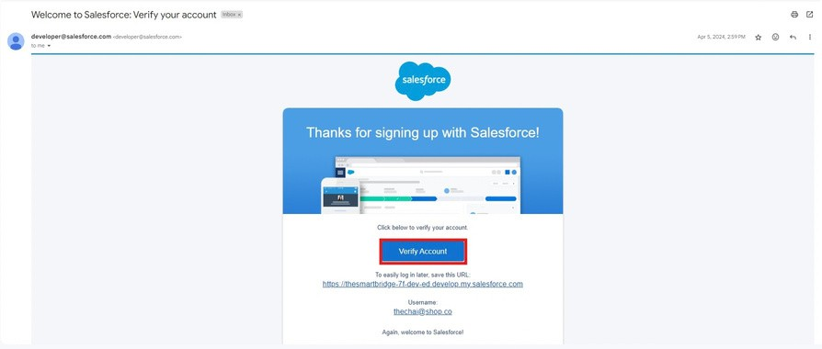
- Click on Verify Account.
- Give a password and answer a security question and click on change password.

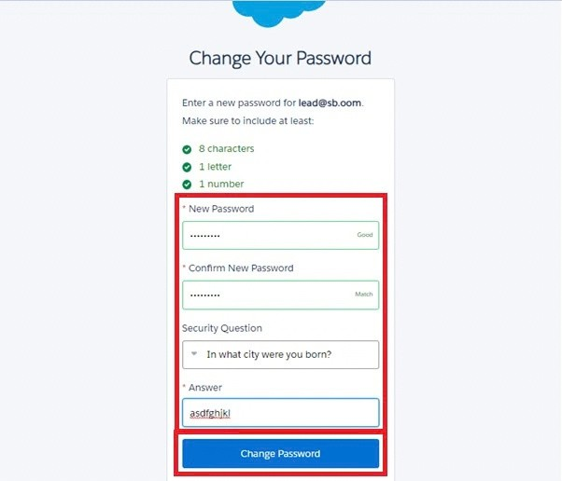

- Then you will redirect to your salesforce setup page.
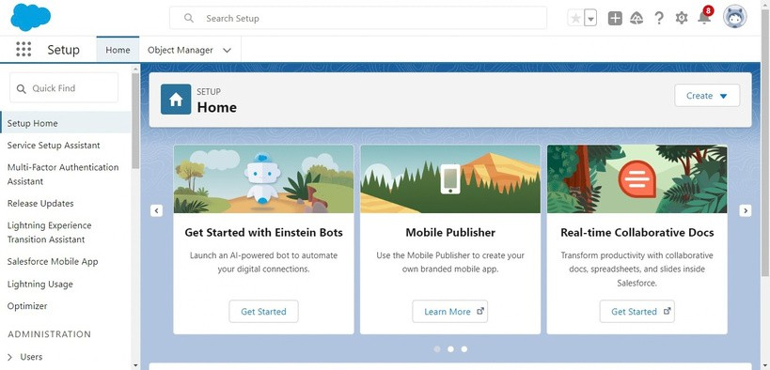

Milestone 2 - Objects

  - In your Salesforce org, click gear icon on the top left and select Setup to open Setup.

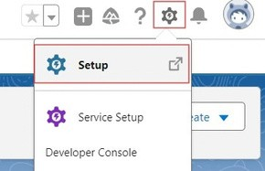

  - Click the Object Manager tab. If you don’t see it, enter Object Manager in the Quick Find box.
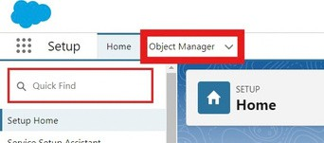

  - On the Object Manager page, click Create | Custom Object.
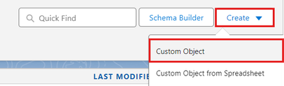

Activity 1 : Employer Account Object

- From the setup page → Click on Object Manager → Click on Create → Click on Custom Object.
  - Label : Employer Account
  - Plural Label : Employer Accounts
  - Enter Record Name Label and Format
Record Name : Employer Account Name Data Type : Text
  - In Optional features : check the boxes for Allow Reports | Allow Activities
| Track Field History.
  - Search Status : check the box for Allow Search.
  - Save

Activity 2 : Customer Account Object

- From the setup page → Click on Object Manager → Click on Create → Click on Custom Object.
  - Label : Customer Account
  - Plural Label : Customer Accounts
  - Enter Record Name Label and Format
Record Name : Customer Account Name Data Type : Text
  - In Optional features : check the boxes for Allow Reports | Allow Activities
| Track Field History.
  - Search Status : check the box for Allow Search.
  - Save

Activity 3 : Enterprise Account Object

- From the setup page → Click on Object Manager → Click on Create → Click on Custom Object.
  - Label : Enterprise Account
  - Plural Label : Enterprise Accounts
  - Enter Record Name Label and Format
Record Name : Enterprise Account Name Data Type : Text
  - In Optional features : check the boxes for Allow Reports | Allow Activities
| Track Field History.
  - Search Status : check the box for Allow Search.
  - Save

Milestone 3 - Tabs

Activity 1 : Custom tabs creation

- Go to setup page → type Tabs in Quick Find bar → click on tabs → New (under custom object tab)

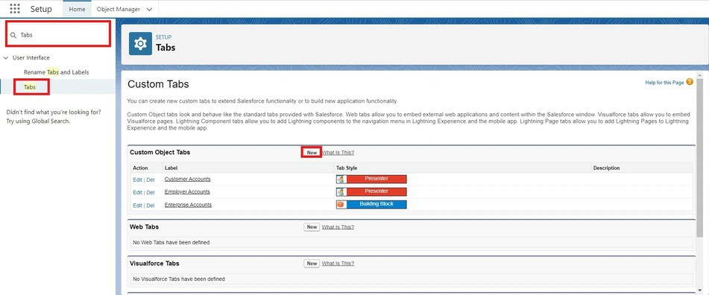

- Select Object(Employer Accounts) → Select the tab style → Next (Add to profiles page) keep it as default → Next (Add to Custom App) uncheck theincludetab .
- Make sure thatthe Append tab to users' existing personal customizations ischecked.
- Click save.
- Repeat the same steps for Customer Accounts and Enterprise Accounts.
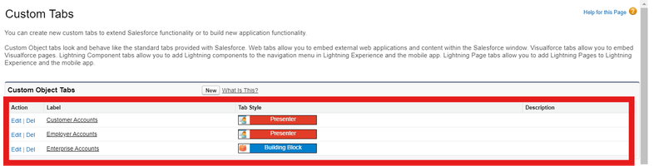

Milestone 4 - The Lightning App

Activity 1 : Create a lightning app

- Go to setup page → search “app manager” in quick find → select “app manager”
→ click on New lightning App.

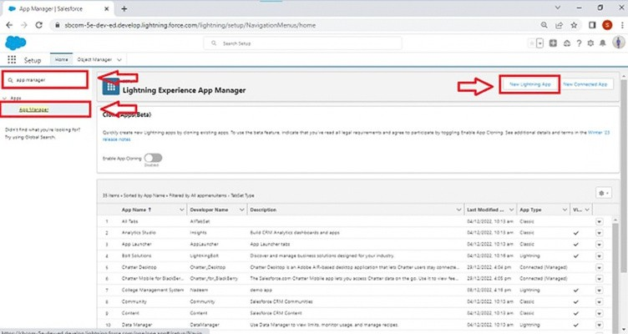

- Fill the app name in app details and branding as follow App Name : TheChaiShop&Co
Developer Name : Auto Populates
Add image optional (if you want to give any image you can otherwise not mandatory) - Add Primary color Hex or leave it to default.
Then click Next.

- In App options
Navigation style : Standard navigation Setup experience : setup
Supporters form factors : Desktop and phone Then click Next

- In Utility items
Utility Bar alignment : Default Then click Next.

- Navigation items
Select the created Custom Objects and required standard objects
  - Customer Accounts Employer Accounts Enterprise Accounts Reports Dashboards

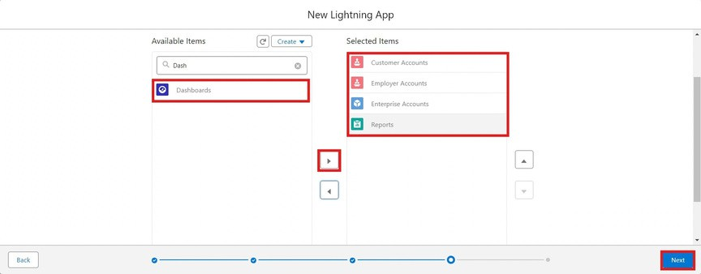

- To Add User Profiles : System Administrator

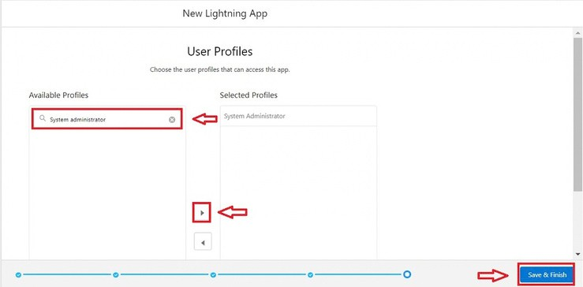

- Click Save & Finish.

Milestone 5 : Global Picklist

Activity 1 : Create Global PIcklist

- In Quick find box search for : Picklist value sets and click New.

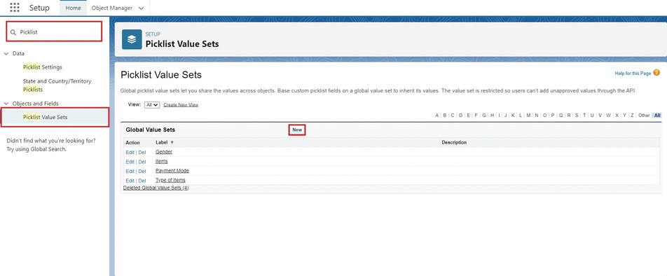

  - Label :Gender
Name :Auto Populates
Values :Male
Female Others
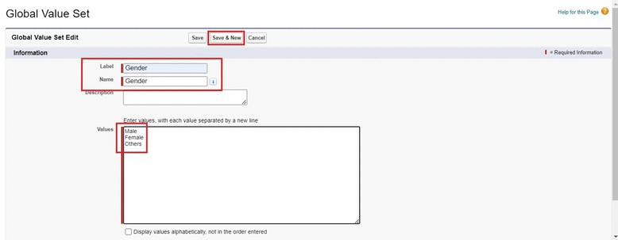
Click Save & New.

- Create three more Global picklists following the same steps.
  - Label : Items
Name : Auto populates
Values : Platinum Tea Powder Double Delight Tea Powder Super Dust Tea Powder
Osmania Biscuits (Value Pack) Osmania Biscuits (Premium Pack) Dry Fruit Biscuits
Fruit Biscuits

Salt Biscuits Multigrain Biscuits Ragi Biscuits
Double Choco Chip Cookies Butter Almond Cookies Melting Moments Cookies Honey Oats Cookies
Delight Box Signature Box Assorted Box
Click Save & New.

  - Label :Payment Mode Name :Auto populates Values :Gpay
PhonePe Paytm
Credit or Debit card Cash.
Click Save & New.

- Label: Typeof Items
Name : Autopopulates Values : Teapowder
Cookies GiftHampers
Click Save.
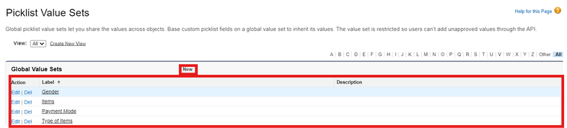

Milestone 6 : Fields & Relationships

Activity 1 : Create Custom fields for Employer Account

- In your Salesforce org, click gear icon on the top left and select Setup to open Setup.
- Click the Object Manager tab. If you don’t see it, enter Object Manager in the Quick Find box.
- From the object manager page, In the Quick Find box, Search for the custom object you just created : Employer Account
- From the sidebar, click Fields & Relationships. Notice that there are already some fields there. Those are the standard fields.
- Click New to create a custom field. Tip: Before creating a new field, do a quick search to make sure a similar one doesn’t already exist.
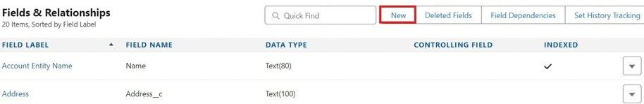

- Next, choose a data type as Text. Choosing a data type helps you format the field input.
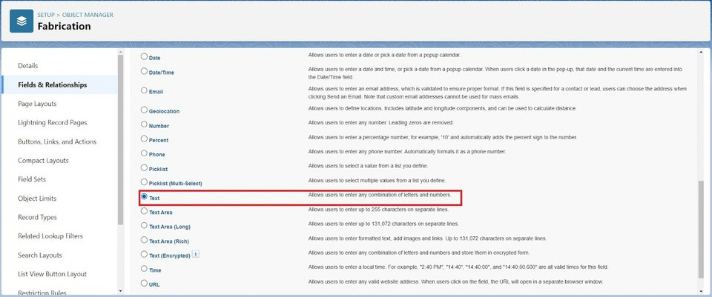

- Click on next.

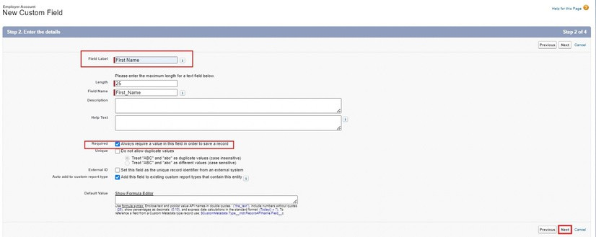

- Data Type : Text Field Label: First Name
Field Name : Auto Populates Length : 25
Required : Check the box
ClickonNext→Next→Save and new.
- Repeat the Same steps for remaining fields

  - Data Type : Text
Field Label: Last Name
Field Name : Auto Populates Length : 25
Required : Check the box
ClickonNext→Next→Saveandnew.

  - Data Type : PickList
Field Label: Gender
Values : Use Global Picklist value set and select Gender from the dropdown menu.
Field Name : Auto Populates. Required : Check the box
Click on Next → Next → Save and new.

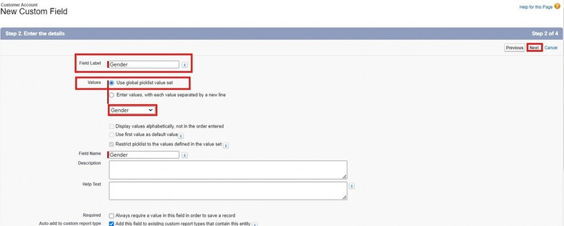

  - Data Type : Phone
Field Label : Phone Number Field Name : Auto Populates Required : Check the box
ClickonNext→Next→Saveand new.

  - Data Type : Email Field Label : Email ID
Field Name : Auto Populates Required : Check the box ClickonNext→Next→Save and new.

  - Data Type : Date
Field Label : Date of Birth Field Name : Auto Populates Required : check the box
ClickonNext→Next→Save and new.

  - Data Type : Text
Field Label : Aadhar Number Field Name : Auto Populates Length : 12
ClickonNext→Next→Saveand new.

  - Data Type : Text
Field Label : PAN Details Field Name : PAN_Details

Length : 10
ClickonNext → Next → Save and new.

  - Data Type : Picklist
Field Label : Designation Field Name : Auto Populates
Value : Enter value, with each value separated by a new line.
Manager
Finance and Accounting Kitchen Staff
Cashier Servers
Click on Next → Next → Save and new.

  - Data Type : Currency
Field Label : Salary
Field Name : Auto Populates
Click on Next → Next → Save.

Activity 2: Create Custom fields for Customer Account

- Data Type : Text
Field Label: First Name Field Name : Auto Populates Length : 25
Required : Check the box
ClickonNext→Next→Save and new.

- Data Type : Text
Field Label: Last Name
Field Name : Auto Populates Length : 25
Required : Check the box
ClickonNext→Next→Save and new.

- Data Type : PickList
Field Label: Gender
Values : Use Global Picklist value set and select Gender from the dropdown menu.

Field Name : Auto Populates. Required : Check the box ClickonNext→Next→Saveand new.

- Data Type : Phone
Field Label : Phone Number Field Name : Auto Populates Required : Check the box
ClickonNext→Next→Saveand new.

- Data Type : Date
Field Label : Date of Birth Field Name : Auto Populates Required : check the box
ClickonNext→Next→Save and new.

- Data Type : Formula
Field Label : Date of Birthday is today ? Field Name : Auto Populates
Formula Return : Checkbox
Formula :
IF( AND(
DAY( TODAY() ) = DAY( Date_of_Birth c ) , MONTH ( TODAY()) = MONTH( Date_of_Birth c )), TRUE,
FALSE)
Click on Next → Next → Save and new.

- Data Type : Email Field Label : Email ID
Field Name : Auto Populates Required : Check the box ClickonNext→Next→Save and new.

- Date Type : Text
Field Label : Address
Field Name : Auto Populates Length : 125 ClickonNext→Next→Save and new.

- Date Type : Multi Select Picklist
Field Label : Type of Items
Values : Use Global Picklist value set and select Type of Items from the dropdown menu. Field Name : Auto Populates.
Required : Check the box
Click on Next → Next → Save and new.

- Date Type : Multi Select Picklist
Field Label : Products purchased
Values : Use Global Picklist value set and select Items from the dropdown menu.
Field Name : Auto Populates. Required : Check the box
Click on Next → Next → Save and new.

- Date Type : Multi Select Picklist
Field Label : Chai
Value : Enter value, with each value separated by a new line.
TheChaiShop&Co Special Tea Single Tea
Masala Tea Lemon Tea Ginger Tea Green Tea Sugar Free Tea
Click on Next → Next → Save and new.

- Data Type : Picklist
Field Label : Payment Mode
Values : Use Global Picklist value set and select Payment Mode from the dropdown menu. Field Name : Auto Populates.
Required : Check the box
Click on Next → Next → Save and new.

- Data Type : Lookup Relationship Related To : Employer Account Field Label : Associated Employer Field Name : Auto Populates ClickonNext→Next→Saveandnew.

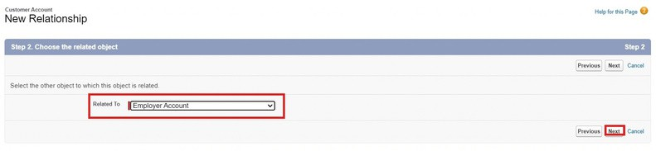

- Data Type : Formula
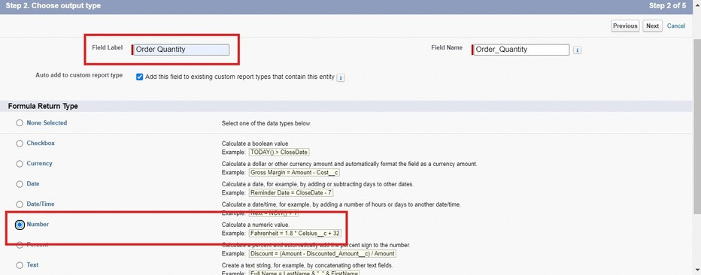
Field Label : Order Quantity Field Name : Auto Populates Formula Return : Number
Enter Formula = Quantity (Number) =
IF(INCLUDES(Products_Purchased c , "Platinum Tea Powder"), 1, 0 ) +
IF(INCLUDES( Products_Purchased c , "Double Delight Tea Powder"), 1, 0 ) + IF( INCLUDES( Products_Purchased c , "Super Dust Tea Powder") , 1, 0) + IF(INCLUDES( Products_Purchased c , "Osmania Biscuits (Value Pack)"), 1, 0 ) +
IF(INCLUDES( Products_Purchased c , "Osmania Biscuits (Premium Pack)"), 1, 0 ) + IF( INCLUDES( Products_Purchased c , "Dry Fruit Biscuits") , 1, 0) +
IF(INCLUDES( Products_Purchased c , "Fruit Biscuits"), 1, 0 ) + IF(INCLUDES( Products_Purchased c , "Salt Biscuits"), 1, 0 ) + IF(INCLUDES( Products_Purchased c , "Multigrain Biscuits"), 1, 0 ) + IF(INCLUDES( Products_Purchased c , "Ragi Biscuits"), 1, 0 ) +
IF( INCLUDES( Products_Purchased c ,"Double Choco chip Cookies") , 1, 0) + IF(INCLUDES( Products_Purchased c , "Butter Almond Cookies"), 1, 0 ) + IF(INCLUDES( Products_Purchased c , "Melting Moments Cookies"), 1, 0 ) + IF( INCLUDES( Products_Purchased c , "Honey Oats Cookies") , 1, 0) + IF(INCLUDES( Products_Purchased c , "Delight Box"), 1, 0 ) +
IF(INCLUDES( Products_Purchased c , "Signature Box"), 1, 0 ) + IF( INCLUDES( Products_Purchased c , "Assorted Pack") , 1, 0) + IF(INCLUDES( Chai c , "TheChaiShop&Co Special Tea"), 1, 0) + IF(INCLUDES( Chai c , "Single Tea"), 1, 0) +
IF(INCLUDES( Chai c , "Masala Tea"), 1, 0) +

IF(INCLUDES( Chai c , "Lemon Tea"), 1, 0) + IF(INCLUDES( Chai c , "Ginger Tea"), 1, 0) + IF(INCLUDES( Chai c , "Green Tea"), 1, 0) + IF(INCLUDES( Chai c , "Sugar Free Tea"), 1, 0)
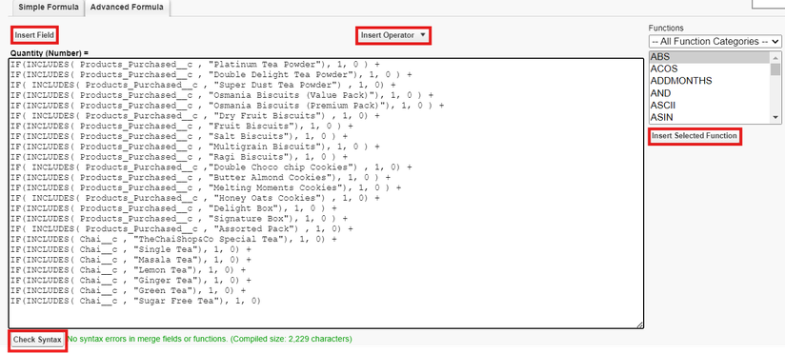
Click on Next → Next → Save and new.

- Data Type : Formula
Field Label : Total Bill
Field Name : Auto Populates Formula Return : Number
Enter Formula = Quantity (Number) =
IF(INCLUDES( Products_Purchased c , "Platinum Tea Powder"), 175, 0 ) + IF(INCLUDES( Products_Purchased c , "Double Delight Tea Powder"), 150, 0 ) + IF( INCLUDES( Products_Purchased c , "Super Dust Tea Powder") , 125, 0) + IF(INCLUDES( Products_Purchased c , "Osmania Biscuits (Value Pack)"), 50, 0 ) +
IF(INCLUDES( Products_Purchased c , "Osmania Biscuits (Premium Pack)"), 80, 0 ) + IF( INCLUDES( Products_Purchased c , "Dry Fruit Biscuits") , 110, 0) + IF(INCLUDES( Products_Purchased c , "Fruit Biscuits"), 160, 0 ) +
IF(INCLUDES( Products_Purchased c , "Salt Biscuits"), 110, 0 ) + IF(INCLUDES( Products_Purchased c , "Multigrain Biscuits"), 170, 0 ) + IF(INCLUDES( Products_Purchased c , "Ragi Biscuits"), 190, 0 ) +
IF( INCLUDES( Products_Purchased c ,"Double Choco chip Cookies") , 200, 0) + IF(INCLUDES( Products_Purchased c , "Butter Almond Cookies"), 110, 0 ) + IF(INCLUDES( Products_Purchased c , "Melting Moments Cookies"), 150, 0 ) + IF( INCLUDES( Products_Purchased c , "Honey Oats Cookies") , 160, 0) + IF(INCLUDES( Products_Purchased c , "Delight Box"), 850, 0 ) +
IF(INCLUDES( Products_Purchased c , "Signature Box"), 1500, 0 ) + IF( INCLUDES( Products_Purchased c , "Assorted Pack") , 600, 0) + IF(INCLUDES( Chai c , "TheChaiShop&Co Special Tea"), 70, 0) + IF(INCLUDES( Chai c , "Single Tea"), 50, 0) +
IF(INCLUDES( Chai c , "Masala Tea"), 60, 0) + IF(INCLUDES( Chai c , "Lemon Tea"), 40, 0) +
IF(INCLUDES( Chai c , "Ginger Tea"),55, 0) + IF(INCLUDES( Chai c , "Green Tea"), 45, 0) +

IF(INCLUDES( Chai c , "Sugar Free Tea"), 55, 0)
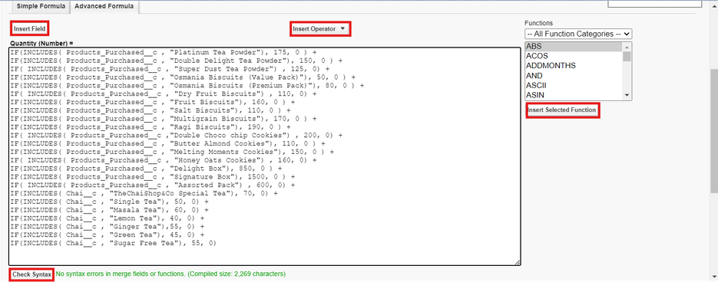
Click on Next → Next → Save.

Activity 3: Create Custom fields for Enterprise Account

- Data Type : Text
Field Label: Enterprise Name Field Name : Auto Populates Length : 25
Required : Check thebox
Click on Next → Next → Save and new.

- Data Type : Phone
Field Label : Phone Number Field Name : Auto Populates Required : Check thebox
Click on Next → Next → Save and new.

- Data Type : Email Field Label : Email ID
Field Name : Auto Populates Required : Check the box
Click on Next → Next → Save and new.

- Date Type : Text
Field Label : Address
Field Name : Auto Populates

Length : 125
ClickonNext→ Next → Save and new.

- Date Type : Multi Select Picklist
Field Label : Type of Items
Values : Use Global Picklist value set and select Type of Items from the dropdown menu. Field Name : Auto Populates.
Required : Check the box
Click on Next → Next → Save and new.

- Date Type : Multi Select Picklist
Field Label : Products purchased
Values : Use Global Picklist value set and select Items from the dropdown menu.
Field Name : Auto Populates. Required : Check the box
Click on Next → Next → Save and new.

- Data Type : Lookup Relationship Related To : Employer Account Field Label : Associated Employer Field Name : Auto Populates ClickonNext→Next→Saveandnew.
- Data Type : Formula
Field Label : Order Quantity Field Name : Auto Populates Formula Return : Number
Enter Formula = Quantity (Number) =
IF(INCLUDES(Products_Purchased c , "Platinum Tea Powder"), 1, 0 ) +
IF(INCLUDES( Products_Purchased c , "Double Delight Tea Powder"), 1, 0 ) + IF( INCLUDES( Products_Purchased c , "Super Dust Tea Powder") , 1, 0) + IF(INCLUDES( Products_Purchased c , "Osmania Biscuits (Value Pack)"), 1, 0 ) +
IF(INCLUDES( Products_Purchased c , "Osmania Biscuits (Premium Pack)"), 1, 0 ) + IF( INCLUDES( Products_Purchased c , "Dry Fruit Biscuits") , 1, 0) +
IF(INCLUDES( Products_Purchased c , "Fruit Biscuits"), 1, 0 ) + IF(INCLUDES( Products_Purchased c , "Salt Biscuits"), 1, 0 ) + IF(INCLUDES( Products_Purchased c , "Multigrain Biscuits"), 1, 0 ) + IF(INCLUDES( Products_Purchased c , "Ragi Biscuits"), 1, 0 ) +
IF( INCLUDES( Products_Purchased c ,"Double Choco chip Cookies") , 1, 0) + IF(INCLUDES( Products_Purchased c , "Butter Almond Cookies"), 1, 0 ) + IF(INCLUDES( Products_Purchased c , "Melting Moments Cookies"), 1, 0 ) + IF( INCLUDES( Products_Purchased c , "Honey Oats Cookies") , 1, 0) + IF(INCLUDES( Products_Purchased c , "Delight Box"), 1, 0 ) +

IF(INCLUDES( Products_Purchased c , "Signature Box"), 1, 0 ) + IF( INCLUDES( Products_Purchased c , "Assorted Pack") , 1, 0)
Click on Next → Next → Save and new.

- Data Type : Formula
Field Label : Total Bill
Field Name : Auto Populates Formula Return : Number
Enter Formula = Quantity (Number) =
IF(INCLUDES( Products_Purchased c , "Platinum Tea Powder"), 175, 0 ) + IF(INCLUDES( Products_Purchased c , "Double Delight Tea Powder"), 150, 0 ) + IF( INCLUDES( Products_Purchased c , "Super Dust Tea Powder") , 125, 0) + IF(INCLUDES( Products_Purchased c , "Osmania Biscuits (Value Pack)"), 50, 0 ) +
IF(INCLUDES( Products_Purchased c , "Osmania Biscuits (Premium Pack)"), 80, 0 ) + IF( INCLUDES( Products_Purchased c , "Dry Fruit Biscuits") , 110, 0) + IF(INCLUDES( Products_Purchased c , "Fruit Biscuits"), 160, 0 ) +
IF(INCLUDES( Products_Purchased c , "Salt Biscuits"), 110, 0 ) + IF(INCLUDES( Products_Purchased c , "Multigrain Biscuits"), 170, 0 ) + IF(INCLUDES( Products_Purchased c , "Ragi Biscuits"), 190, 0 ) +
IF( INCLUDES( Products_Purchased c ,"Double Choco chip Cookies") , 200, 0) + IF(INCLUDES( Products_Purchased c , "Butter Almond Cookies"), 110, 0 ) + IF(INCLUDES( Products_Purchased c , "Melting Moments Cookies"), 150, 0 ) + IF( INCLUDES( Products_Purchased c , "Honey Oats Cookies") , 160, 0) + IF(INCLUDES( Products_Purchased c , "Delight Box"), 850, 0 ) +
IF(INCLUDES( Products_Purchased c , "Signature Box"), 1500, 0 ) + IF( INCLUDES( Products_Purchased c , "Assorted Pack") , 600, 0)

- Data Type : Picklist
Field Label : Payment Mode
Values : Use Global Picklist value set and select Payment Mode from the dropdown menu. Field Name : Auto Populates.
Required : Check the box
Click on Next → Next → Save.

Milestone 7 : Page Layouts
For the personalized field view in Customer Accounts, let's create two page layouts Online orders and Walk-In orders.

Activity 1: Online Orders page layout
- Go to the setup page → click on object manager → From drop down click edit for
Customer Account object.

- Click on the Page Layouts → click New.

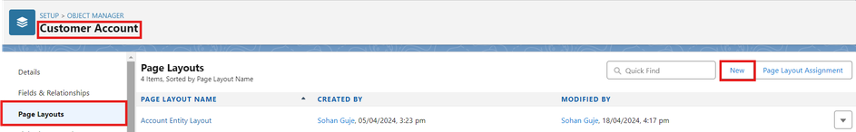

- Page Layout Name : Online Orders and click Save.
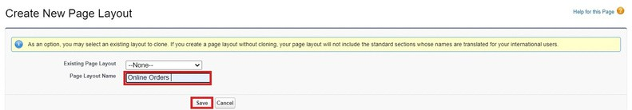

- Drag and Arrange all the required fields as shown below.
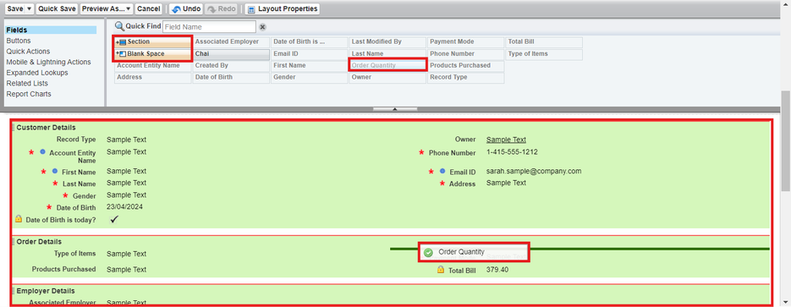

- Click Save.

Activity 2: Walk-In Orders page layout

- Gotothesetuppage→clickonobjectmanager→From drop down click edit for
Customer Account object.

- Click on the Page Layouts → click New.

- Page Layout Name : Walk-In orders and click save.

- Drag and Arrange all the required fields as shown below.
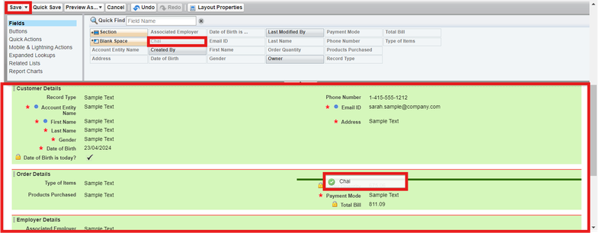

- Click Save.

Milestone 8 - Record Types
To Differentiate the records and data stored in Customer Accounts, let's create two different Record Types.
Online orders and Walk-In orders.

Activity 1: Online Orders Record Type

- Gotothesetuppage→click on object manager → From drop down click edit for
Customer Account object.

- Click on the Record Types → click New.
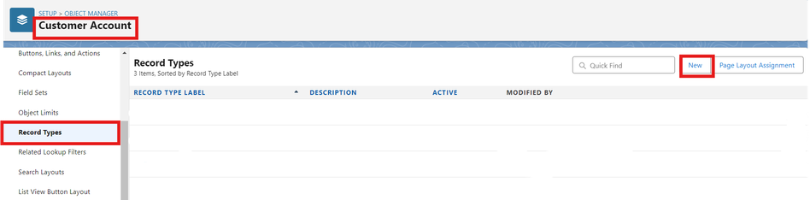

- Enter Details :
Existing Record Type : Master Record Type Label : Online Order

Record Type Name : Auto Populates Active : Tick the checkbox
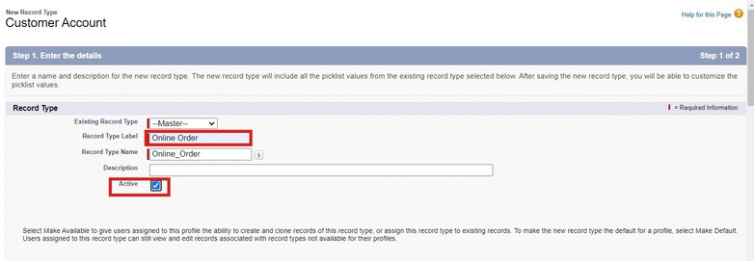
Click Next

- In Assign Page Layouts
  - Select Apply one layout to all profiles : select down menu.

Online orders from the drop

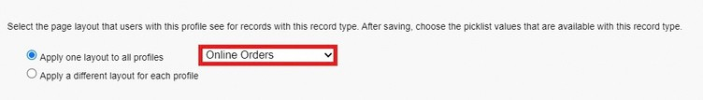

- Click Save and New.

Activity 2: Walk-In Orders Record Type

- Gotothesetuppage→clickonobject manager → From drop down click edit for
Customer Account object.

- ClickontheRecordTypes→clickNew.

- Enter Details :
Existing Record Type : Master Record Type Label : Walk-In Order Record Type Name : Auto Populates Active : Tick the checkbox
Click Next

- In Assign Page Layouts

  - Select Apply one layout drop down menu.

- Click Save.
to all profiles : select
Walk-In orders from the

Milestone 9 - Validation Rules Activity 1: On Employer Account
- Gotothesetuppage→click on object manager → From drop down click edit for
Employer Account object.

- Click on the validation rule → click New.
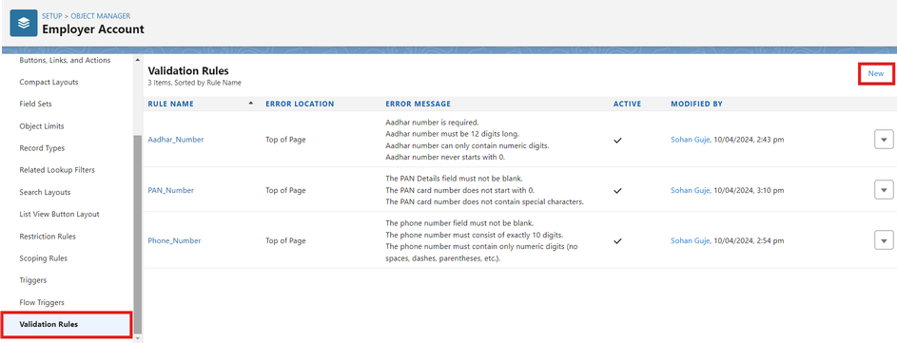

- Enter Rule Name : Aadhar Number

Error Condition Formula :
AND(
NOT(ISBLANK( Aadhar_Number c )), LEN( Aadhar_Number c ) <> 12,
NOT(REGEX( Aadhar_Number c , "^[1-9]{12}$"))
)

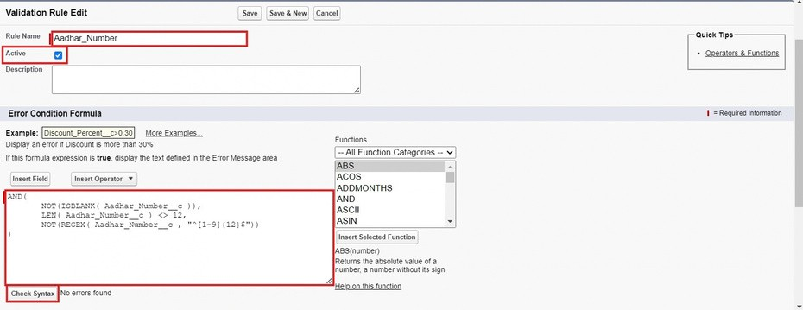

- Error Message : Aadhar number is required.
The Aadhar number must be 12 digits long. Aadhar number can only contain numeric digits. Aadhar number never starts with 0

- Click Save &New.
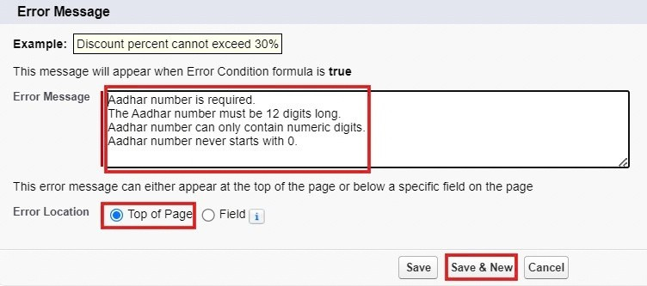

- Repeat the same steps and create two more validation rules on the employer account object.

  - Enter Rule Name : PAN Number

Error Condition Formula :
AND(
NOT(ISBLANK( Phone_Number c )), NOT(REGEX( Phone_Number c , "^[1-9]{10}$")),

NOT(REGEX( Phone_Number c , "^\\d+$"))
)

Error Message : The PAN Details field must not be blank.
The PAN card number does not start with 0.
The PAN card number does not contain special characters.

Click Save &New.

  - Enter Rule Name :Phone Number

Error Condition Formula :
AND(
NOT(ISBLANK( Phone_Number c )), NOT(REGEX( Phone_Number c , "^[1-9]{10}$")), NOT(REGEX( Phone_Number c , "^\\d+$"))
)

Error Message :
The phone number field must notbeblank.
The phone number must consistofexactly 10 digits. The phone number must containonlynumeric digits (no spaces, dashes, parentheses,etc.)

Click Save.

Activity 2: On Customer Account

- Gotothesetuppage→click on object manager → From drop down click edit for
Customer Account object.

- Click on the validation rule → click New.

- Enter Rule Name : Phone Number

Error Condition Formula :
AND(
NOT(ISBLANK( Phone_Number c )), NOT(REGEX( Phone_Number c , "^[1-9]{10}$")), NOT(REGEX( Phone_Number c , "^\\d+$"))
)

Error Message :
The phone number field must notbeblank.

The phone number must consist of exactly 10 digits. The phone number must contain only numeric digits (no spaces, dashes, parentheses, etc.)

- Click Save.

Activity 3: On Enterprise Account

- Gotothesetuppage→click on object manager → From drop down click edit for
Customer Account object.

- Click on the validation rule → click New.

- Enter Rule Name : Phone Number

Error ConditionFormula
:
AND(
NOT(ISBLANK(Phone_Number c )), NOT(REGEX(Phone_Number c , "^[1-9]{10}$")), NOT(REGEX(Phone_Number c , "^\\d+$"))
)

Error Message :
The phone number field must notbeblank.
The phone number must consistofexactly 10 digits. The phone number must containonlynumeric digits (no spaces, dashes, parentheses,etc.)

- Click Save.

Milestone 10 - Email Template

Activity 1: Email Template

- Go to setup, In quick find box enter Email template → click on classic Email Template.

- Click on→ New Email Template

- Choose the type of email template you would like to create : Text and click Next.

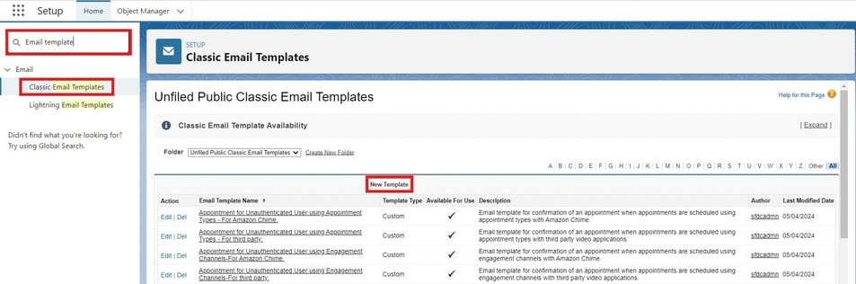
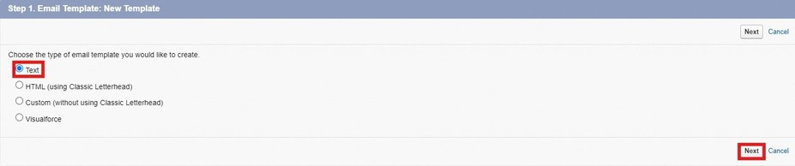

Available Merge Fields
Select Field Type : Customer Accounts Fields
Select Field : First Name
Copy Merge Field value :Auto Populates, Copy the value and paste it in the email body where required.

- Folder : Unfiled public Classic Email templates
- Click on available for use
- Email Template Name is “Birthday Offer Email”
- Template Unique Name : Auto populated
- Subject : Special Birthday Offer Inside!
- Email body :
Dear {!Customer_Account c.First_Name c},

Happy Birthday from all of us at TheChaiShop&Co! 🎉🎂 We hope your special day is filled with joy, laughter, and wonderful memories.

To celebrate your birthday, we have a special gift just for you! As a token of our appreciation for your continued support, we're delighted to offer you an exclusive birthday discount.
🎁 Birthday Offer: Enjoy a fantastic 50% off on your next purchase as our birthday gift to you!

This offer is our way of saying thank you for being a valued customer. Simply use the code [HBDAY50] at checkout to redeem your birthday treat.

We hope this special offer adds a little extra sparkle to your birthday celebrations!

Once again, happy birthday! Thank you for choosing TheChaiShop&Co! and being part of our community.

Warm regards TheChaiShop&Co!
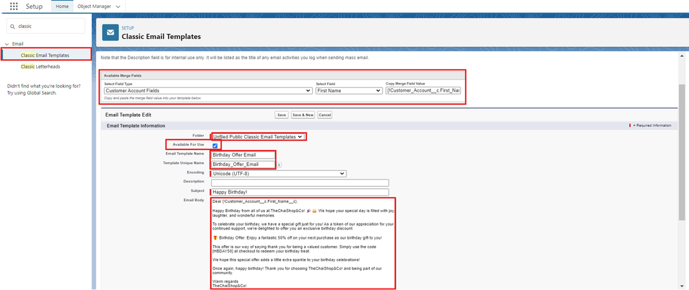

- Click Save.

Activity 2: Email Alert

- Go to setup, In quick find box enter Email Alert → click on Email Alert .
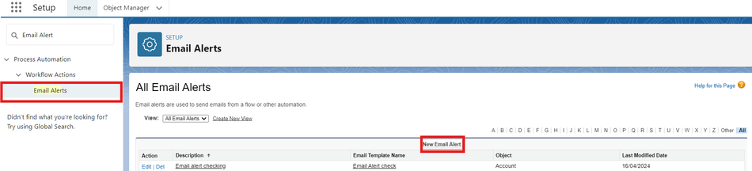

- Click on New Email Alert.

- Description : Happy Birthday email alert
Unique Name : Auto Populates

Object :CustomerAccount
Email Template :Search for Birthday Offer Email Recipient Type :Search : Email field : Email ID
From Email Address : Default Workflow user’s email address Click Save.
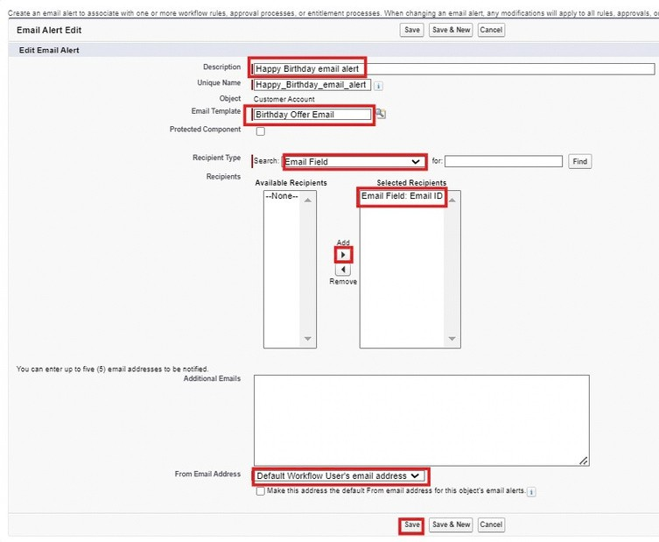

NOTE :

- Make sure that the Default workflow user is assigned.

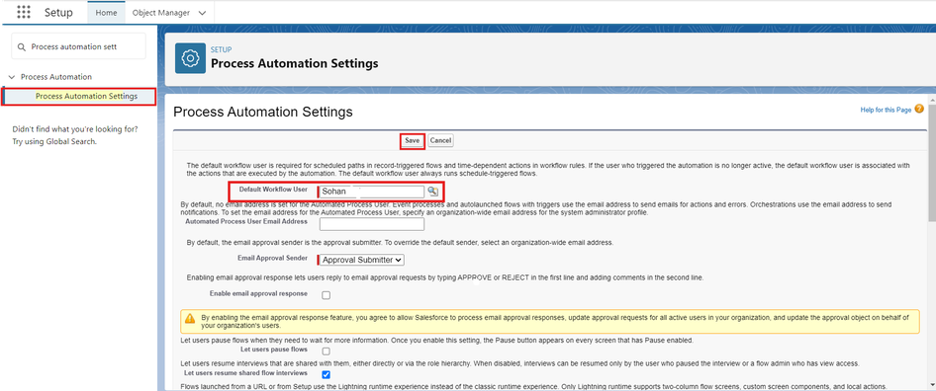

Milestone 11 - Flows
Let’screateascheduledTriggered flow to automate the Birthday offer mails.

Activity 1: Schedule Triggered Flow

- Go to setup, Type Flow in quick find box → Click on the Flow and Select the New Flow.
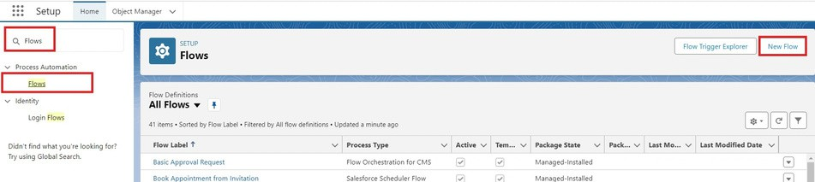

- Select Schedule - Triggered Flow and click Create.

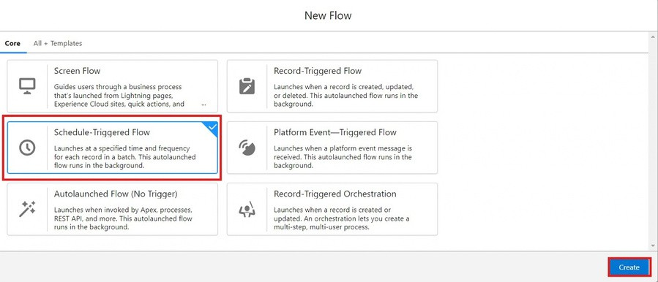

Set a Schedule
Start Date : Enter the Date, when you want to start the flow. Start Time : Enter the Time, when you want to start the flow. Frequency : Daily
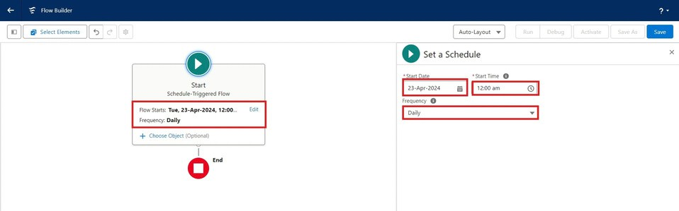

Create Object
Object : Customer Account
Condition Requirements : All conditions Are Met (AND)
  - Field : Date_of_Birthday_is_today c Operator : Equals
Value : $GlobalConstant.True
  - Field : Email_ID_c Operator : IS NULL
Value : $GlobalConstant.False

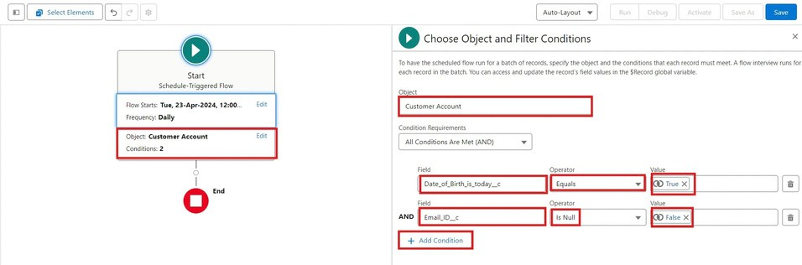

- Click (+) Icon on the flow builder and Select Action Component.
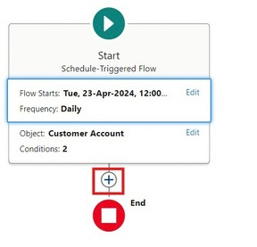
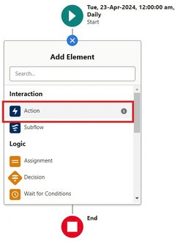

- In New Action Page
Filter By : Type and select Email Alert
In Action : Search and select Happy Birthday email alert
Label : Send Happy Birthday Email
API Name : Auto Populates
Set Input Values for the Selected Action : Record ID : {!$Record.Id}

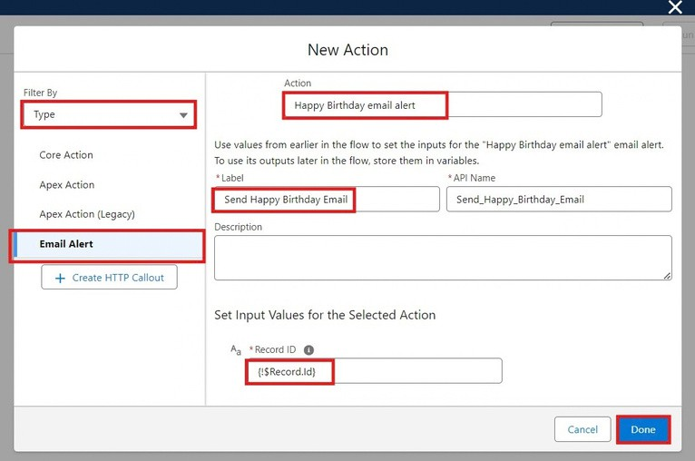
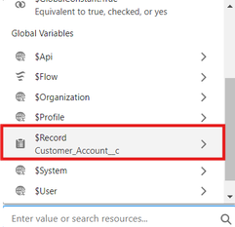
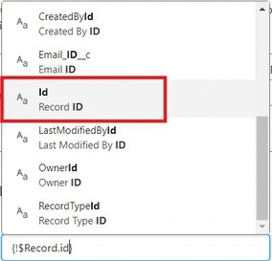

- Click Done.

- Click Save on the top right
Flow Label : Happy Birthday Email Flow Flow API Name : Auto Populates
Click Save.

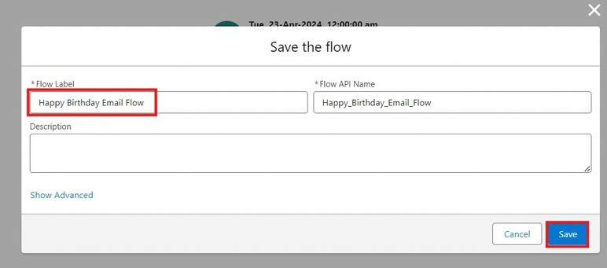

- Click Activate.
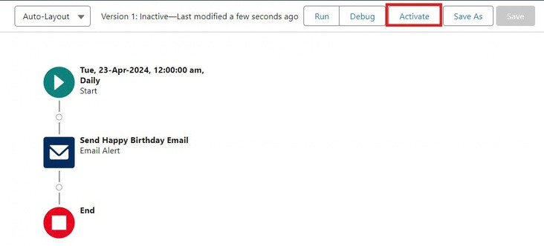

Milestone 12 - Reports & Dashboards Activity 1: Customer Account Sales Report

- Click App Launcher
- Click Reports
- Click New Report
and select TheChaiShop&Co.

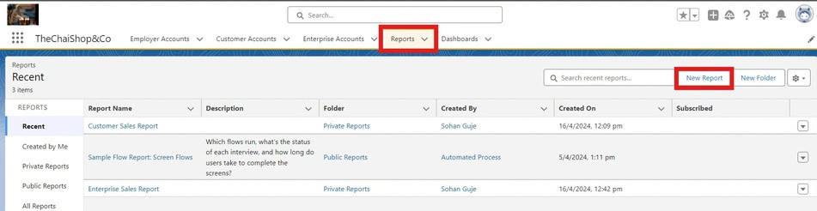

- In search type Customer Accounts and Select Customer Accounts.
- Click Start Report.
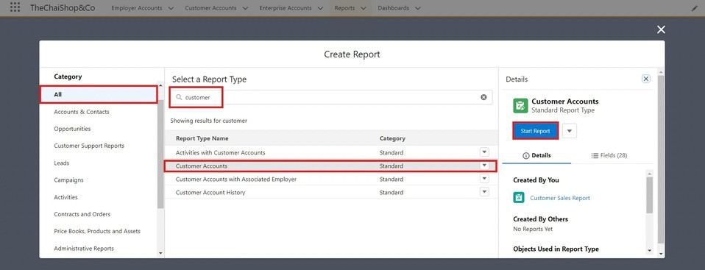

- Click the toggle Update Preview Automatically to ON.
- Drag and Drop all the required Columns from the Outline pane.
- Group Rows : Search and Select
Customer Account: Record Type
- Click Add Chart on the top.
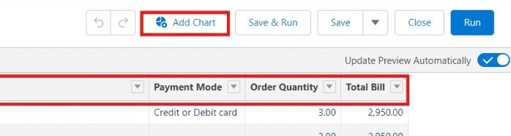

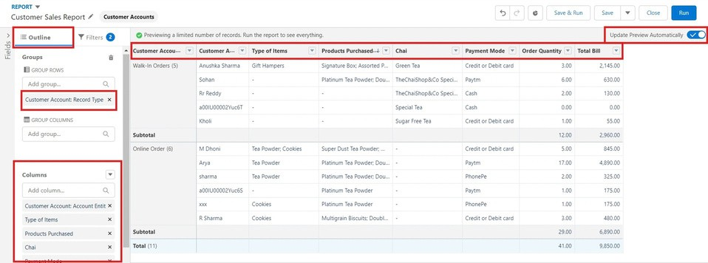

- Click Save on the top right. Enter
Report Name: Customer Account Sales Report Report Unique Name : Auto Populates
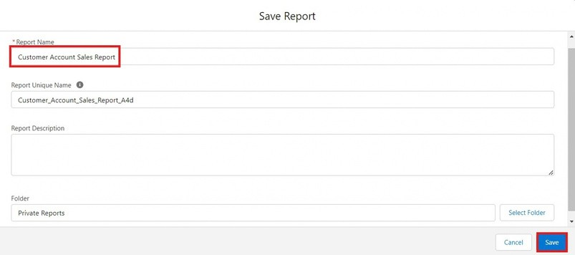
Click Save.

Activity 2: Enterprise Account Sales Report
- Repeat the same steps to create another report.
- Click Reports
- Click New Report
- In search type Enterprise Accounts and Select Enterprise Accounts.
- Click Start Report.
- Click the toggle Update Preview Automatically to ON.
Drag and Drop all the required Columns from the Outline pane.

Group Rows : Search and Select
Type of Items.
- Click Add Charton the top.
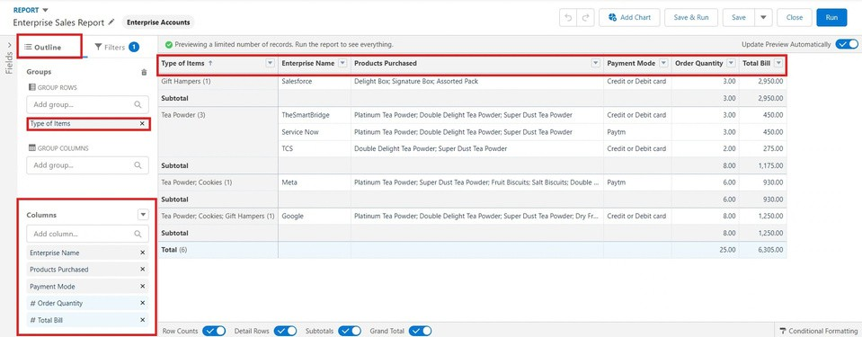

- ClickSave on the top right. a.Enter
  - Report Name : Enterprise Account Sales Report
  - Report Unique Name : Auto Populates
  - Click Save.
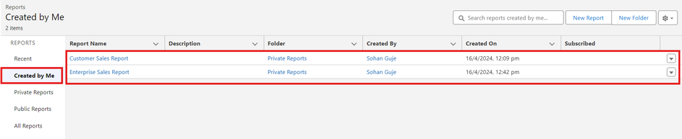

Activity 3: Dashboard

- Click Dashboards
- Click New Dashboards
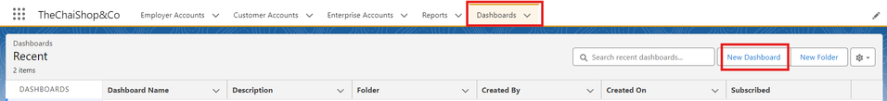

- Name : Customer Vs Enterprise Sales
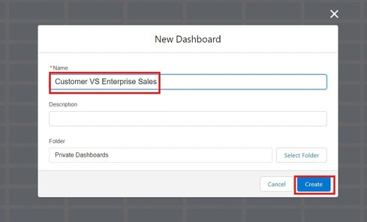
- Click Create.
- Click Widget
- Select Chart or Table.
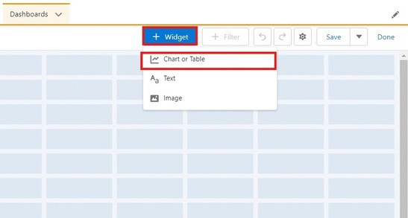

- Select Customer Account Sales Report
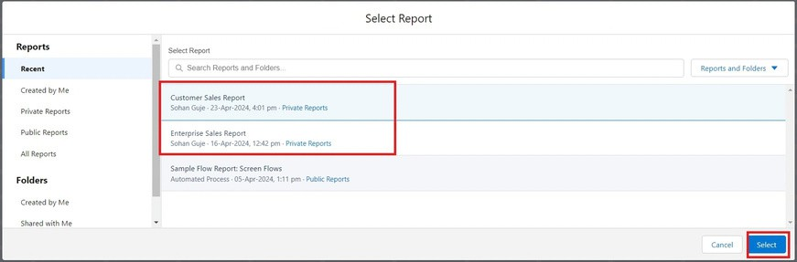

- Display As : Select the one which you feel comfortable with.
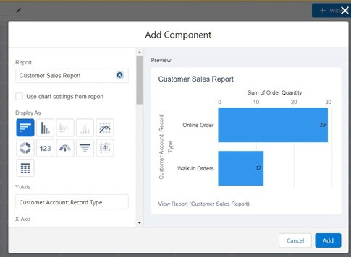
- Click Add.

- Repeat the same steps for the Enterprise Account Sales Report.
- Click Save.
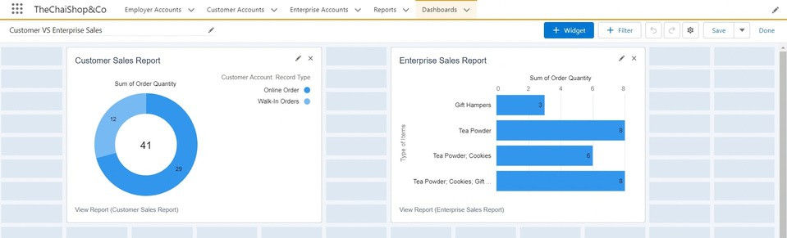

Milestone 12 - Conclusion

In conclusion, the development of TheChaiShop&Co CRM application marks a significant stride in enhancing the store's operational efficiency and customer relationship management capabilities. Seamlessly integrating employer details, customer information (both online and offline), and enterprise data, this application streamlines business processes and enables informed decision-making. The automation of sales calculations, including order quantity and total bill amount, reduces errors and empowers employees to focus on delivering exceptional service. Moreover, automated email notifications for customers' birthdays foster personalized communication and enhance customer engagement.

FUNCTIONAL & PERFORMANCE TESTING

During the testing phase, screenshots were captured from the Salesforce Lightning interface to verify correct system behavior. These include:

  - Record creation for Employer, Customer, and Enterprise objects
  - Validation rule testing for Aadhar, PAN, and phone numbers
  - Verification of record types and page layouts
  - Formula field validation for order quantity and billing
  - Flow execution for birthday email alerts
  - Report and dashboard generation

Performance testing ensured fast response time and system stability during concurrent usage.

ADVANTAGES & DISADVANTAGES

Advantages

  - Centralized data management

  - Reduced manual work
  - Automated calculations
  - Improved customer engagement
  - Real-time analytics

Disadvantages

  - Requires Salesforce license
  - Internet dependency
  - Limited offline access

Conclusion:

The CRM Application for TheChaiShop&Co successfully improves business operations by integrating customer data, automating billing, and enabling intelligent reporting. The system reduces errors, saves time, and enhances customer relationships through automation and analytics.

FUTURE SCOPE

  - Mobile CRM integration
  - AI-based sales prediction
  - WhatsApp/SMS alerts
  - Inventory management
  - Multi-branch support
  - Advanced customer profiling

APPENDIX
Source Code : Salesforce Configuration & Flows

Dataset : Customer and Sales Records

Tools Used : Salesforce Developer Org

Thank You

